SCHOOLOFCOMPUTER SCIENCE AND ARTIFICIAL INTELLIGENCE |  |  |  |  | DEPARTMENTOFCOMPUTER SCIENCE ENGINEERING
ProgramName:M.Tech/MCA/MSC |  |  |  | AssignmentType: Lab |  |  | AcademicYear:2025-2026
CourseCoordinatorName |  |  |  | Venkataramana Veeramsetty
CourseCode |  |  |  | CourseTitle |  | AI Assisted Problem Solving Using Python
AssignmentNumber:16.3(Presentassignmentnumber)/24(Totalnumberofassignments)
NAME: SYEDA AFIFA FATHIMA ROLLNUMBER:2503B05142
 | Q.No. | Question
 | Q1. | Lab 16 – Database Design and Queries: Schema Design and SQL Generation  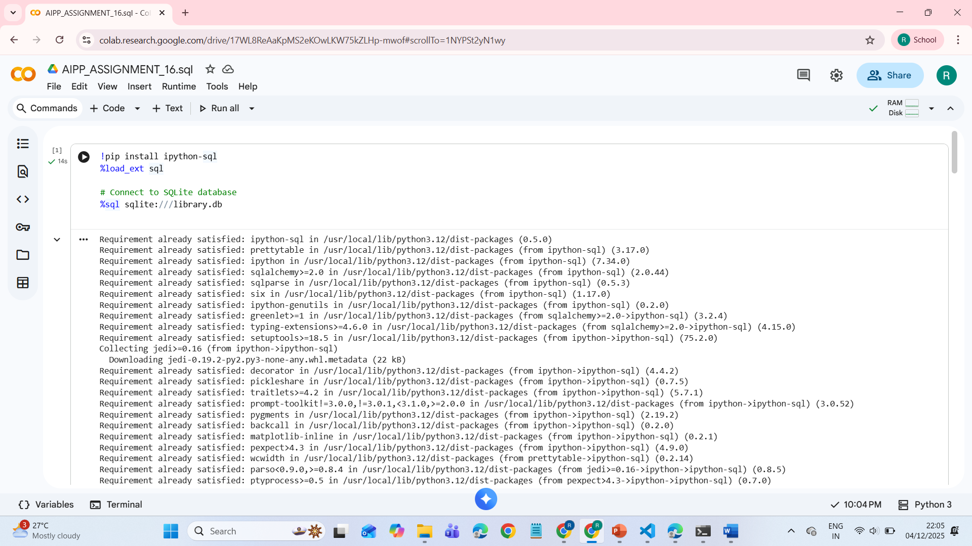  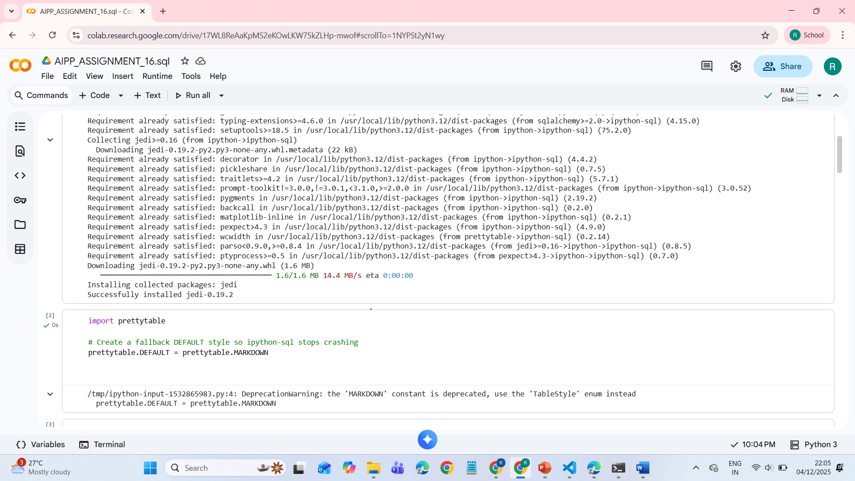  Task Description #1 – Schema Generation  Task: Ask AI to design a schema for a Library Management System (Tables: Books, Members, Loans).  SQL Code  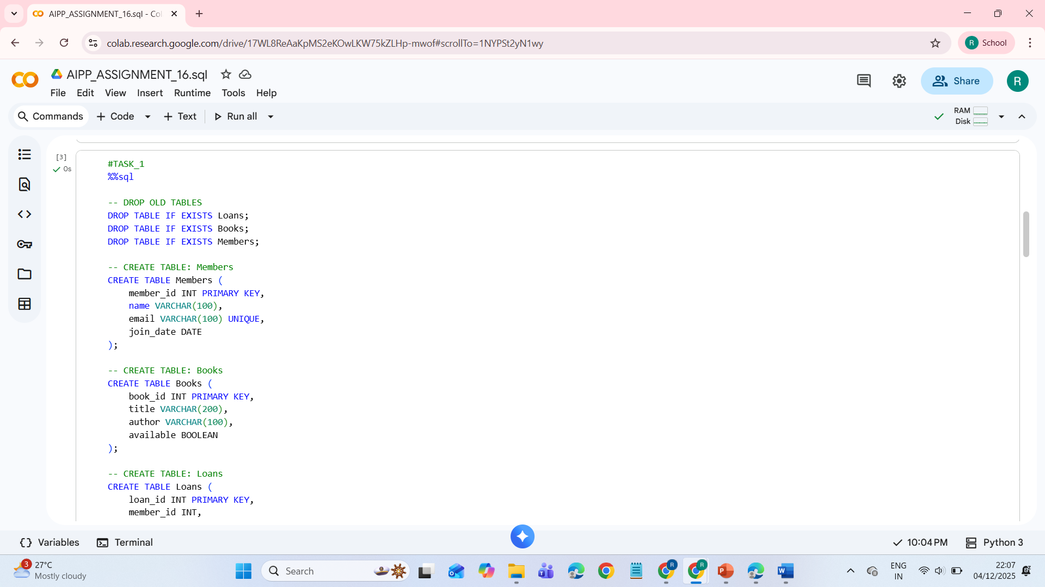  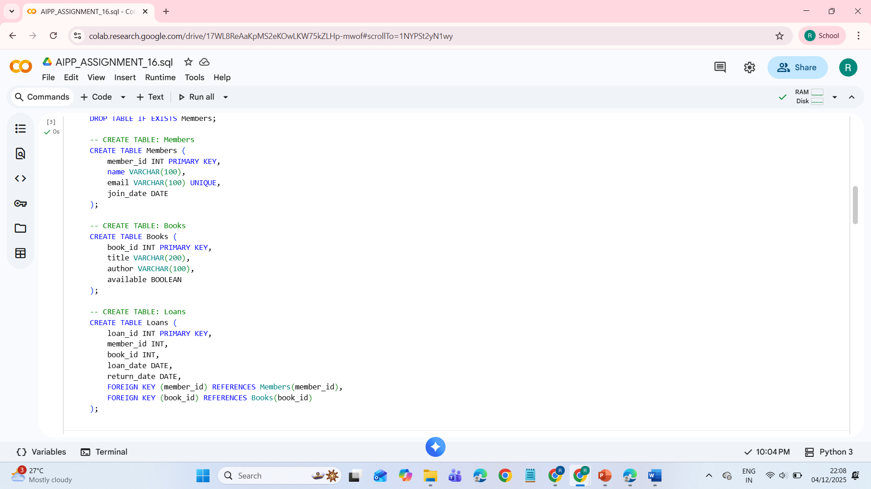  OUTPUT:  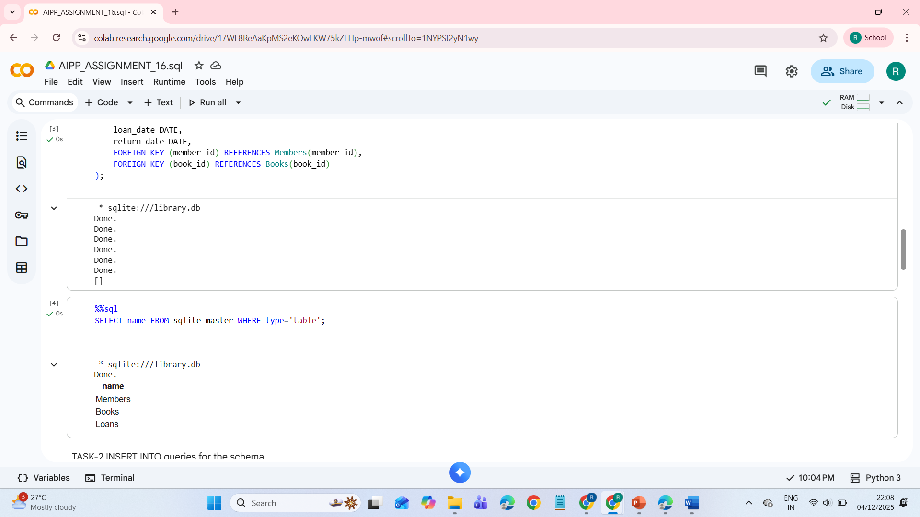  Task Description #2 – Error Insert Data  Task: Ask AI to generate INSERT INTO queries for the schema above (3 sample records per table).  CODE:  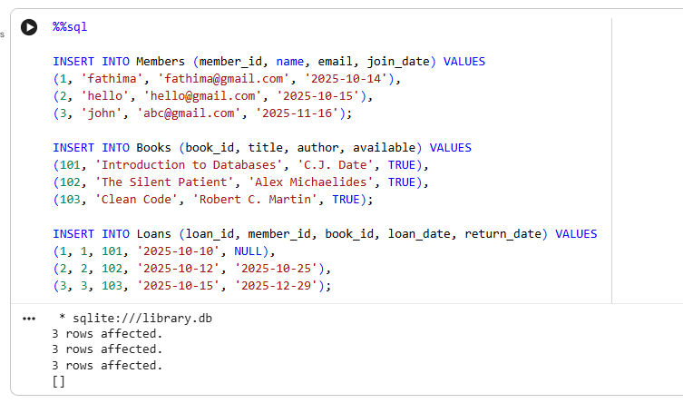  Task Description #3 – Basic Queries  Task: Use AI to generate a query to list all books borrowed by a specific member  CODE:  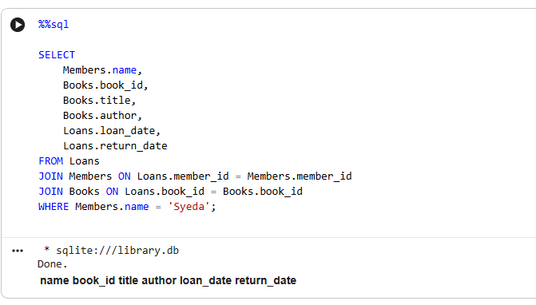  Task Description #4 – Update and Delete Queries  Task: Generate queries with AI for:  - Updating a book’s availability to FALSE when borrowed.  - Deleting a member record safely.  CODE:  